An Interim Report for term project

**Computer Graphics 2016 Spring semester**

1. **Team Members**

2013190711 이민주

2013210065 정윤송

1. **Summery**

This project aims to a running game of Pikachu. The game character is Pikachu and he runs along the forest with some obstacles such as Team Rocket members. The final goal of the game is to meet Ji-woo at the end and run as far as he can. The score is determined by how far the Pikachu runs. Pikachu would be better to get Thunder so he can buy the clothes for its own beauty. There is a ranking system based on the distance and the score is saved so that the player can update their own records. The player can control Pikachu by swiping the screen to the left and right. Our goal is to upload it to the Tizen Store.

1. **Development Environment**

OS : Tizen

Game engine : Unity

3D tool: Maya



1. **Role**

정윤송 : Pikachu , Ji-woo Modeling, make obstacles pop up randomly, scoring system

이민주 : Background, Rocket members Modeling, report

Programming the game app will be done together.

1. **What we have done so far**
2. Studied about unity. Had some lectures about how to use unity.
3. Since our project is let pikachu run avoiding obstacles, we implemented a function that let characters run.

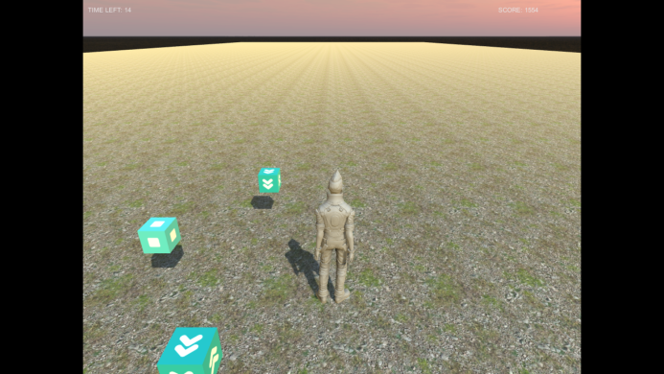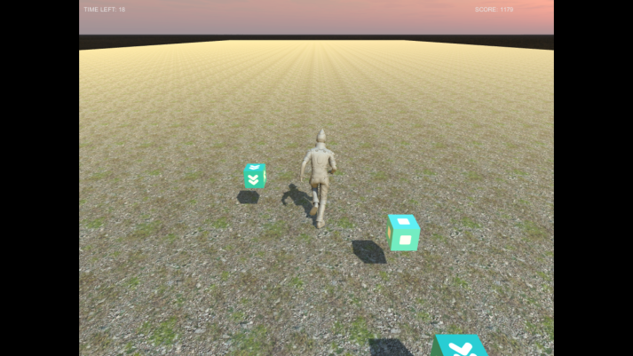

1. Also, put let obstacles pop up randomly.
2. We had to use Maya to make characters, like pikachu, rocket memebers etc, so we studied how to use Maya and on the way to modeling those characters.
3. Implemented scoring system
4. When game over, there’s game over screen.

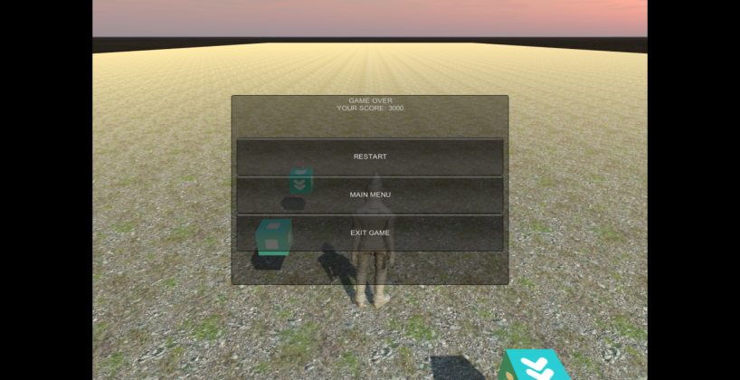

1. **Troubles we are facing**
2. This is little big troubles that since we are all new to making games, we have to study first and implement it, so we are little behind the schedule than we expected.
3. Also, 윤송’s laptop can’t play the thing we made in tizen app so we need to check it by 민주’s laptop every time.
4. Sometimes, it’s hard to use Github for uploading.
5. **What should we do from now on**
6. First, try to finish making characters as soon as possible and make it looks like actual characters as we can.
7. Try to connect scoring system to facebook, so users can compete with other users.
8. **Schedules**

We try to have meeting at least once a week and upload it to Github.

6/9 Finish making all characters and put it together

6/14 face book contact sync

6/15 Feedback -> upload to Tizen store